Lab 3 Resistor Specifications
Pre-Lab Questions
Review the sample datasheet shown in Figure 1.0 and identify the following specifications:
- Nominal resistance
Answer: 1.0 kΩ (1000 Ω).
- Resistance tolerance
Answer: ±5%.
- Minimum allowable resistance
Answer: 950 Ω. Rmin = 1000(1 − 0.05) = 950 Ω.
- Maximum allowable resistance
Answer: 1050 Ω (1.05 kΩ). Rmax = 1000(1 + 0.05) = 1050 Ω.
- Maximum power rating
Answer: 0.5 W (rated through 70 °C ambient).
- Operating temperature range
Answer: −55 °C to +155 °C.
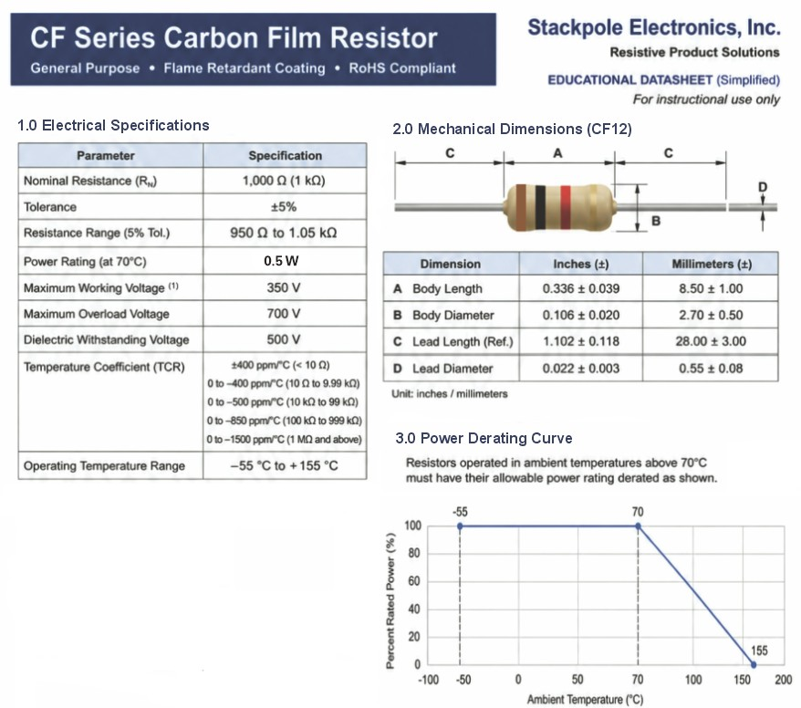
Figure 1.0 Simplified datasheet for a 1 kΩ, ±5%, 0.5 W carbon film resistor.
- What is the minimum allowable resistance for this 1 kΩ resistor with 5% tolerance?
Answer: Rmin = 1000(1 − 0.05) = 950 Ω.

- What is the maximum allowable resistance for this 1 kΩ resistor with 5% tolerance?
Answer: Rmax = 1000(1 + 0.05) = 1050 Ω.
- What is the minimum allowable resistance for a 1 kΩ resistor with 1% tolerance?
Answer: Rmin = 1000(1 − 0.01) = 990 Ω.
- What is the maximum allowable resistance for a 1 kΩ resistor with 1% tolerance?
Answer: Rmax = 1000(1 + 0.01) = 1010 Ω.
- A 1 kΩ resistor has a specified tolerance of ±1%. Its measured resistance is 1024 Ω. Does it meet the specification? Explain your answer.
Answer: No. Percent difference = (1024 − 1000)/1000 × 100% = 2.4%.
Since +2.4% is greater than the allowed +1%, 1024 Ω is outside the 990–1010 Ω specification.

- When measuring many 1 kΩ resistors with ±5% tolerance, would you predict that values are equally common throughout 950–1050 Ω, or more common near a central value? Describe your predicted distribution. Does the tolerance specification alone determine its shape? Explain.
Answer: Values would generally be more common near the nominal/central value and less common near 950 Ω or 1050 Ω (often approximately bell-shaped).
The ±5% tolerance defines only the allowable 950–1050 Ω range; it does not, by itself, determine the distribution shape.

- From the power derating curve in Figure 1.0, what is the maximum ambient temperature at which this resistor may dissipate its full rated power of 0.5 W?
Answer: 70 °C. The resistor may dissipate its full 0.5 W through 70 °C ambient.

- From the power derating curve in Figure 1.0, what is the maximum allowable power at an ambient temperature of 85°C?
The derating is linear from 100% at 70 °C to 0% at 155 °C:
Power fraction at 85 °C = (155 − 85)/(155 − 70) = 70/85 = 0.8235.
Pmax = 0.5 W × 0.8235 = 0.412 W ≈ 0.41 W.
- If the power supply in the lab is limited to a maximum voltage of 30 V per channel (on channels 2 and 3), how can you configure the instrument to create a voltage of 45 V?
Connect CH2 (+) to CH3 (−), then use the remaining CH2 (−) and CH3 (+) terminals as the output (channels must be isolated/floating).
Set the channel voltages to total 45 V, e.g., 22.5 V + 22.5 V = 45 V.
- When measuring DC voltage with a DMM, is the meter connected in series or in parallel with the component being measured?
Answer: Parallel across the component.
- When measuring resistance with a DMM, is the meter connected in series or in parallel with the component being measured?
Answer: Parallel across the component terminals, with the circuit unpowered (ideally isolate one lead if parallel paths exist).
- When measuring resistance with a DMM, can the component be powered by an external source?
Answer: No. De-energize and discharge the circuit before measuring resistance.

- If the voltage across a resistor doubles, how does the power dissipation change? Explain using an equation.
P = V²/R. If voltage doubles, P′ = (2V)²/R = 4V²/R = 4P.
Therefore, the power dissipation quadruples.

- What is the equivalent resistance of three 10 kΩ resistors connected in parallel?
1/Req = 1/10000 + 1/10000 + 1/10000 = 3/10000.
Req = 10000/3 = 3333 Ω ≈ 3.33 kΩ.
- A DC Power Supply with 40 V output is applied to three 10 kΩ resistors connected in parallel, together do these dissipate approximately the same power as the single 3.3 kΩ resistor? Show your equations.
Three 10 kΩ resistors in parallel: Ptotal = V²/Req = 40²/3333 = 0.480 W.
Single 3.3 kΩ resistor: P = 40²/3300 = 0.485 W. These are approximately the same (about 1% difference).

